The Islamia University of Bahawalpur
Department of Information Technology



SOFTWARE REQUIREMENTS SPECIFICATION
(SRS DOCUMENT)
for
Online Voting System

Version 1.0
By
Rao Asif Javed
Roll No: F22BINFT1M01179
Session Fall 2022 – 2026

Supervisor
Dr. Rizwan Ali Shah

Bachelor of Information Technology

Table of Contents
Version 1.0 1
Revision History 1
Application Evaluation History 2
Introduction: 3
Overall description 4
Requirement identifying technique: 4
Functional Requirements: 8
System Features and Functional Requirements 8
Functional Requirements with Specific Features: 9
Nonfunctional Requirements for the Online Voting System 11
References: 17

Revision History

Name | Date | Reason for changes | Version

Application Evaluation History

Comments (by committee)  *include the ones given at scope time both in doc and presentation | Action Taken

Supervised by: Dr.Rizwan Ali Shah

Signature

Introduction:
Web based online voting system that will help you manage your elections easily and securely. This voting system can be used for casting votes during the election. In this the system the voter does not have to go to the polling booth to cast their vote. They can use their personal computer to cast their votes. There is a database in which is maintained in which all the name of the voters with their complete information is stored. The admin registers the voters by simply filling a registration from a register the voters. After registration, the voter is assigned a secret voter ID with which he/she can use to login to the system and cast his/her vote.

Purpose:

Online Voting System is a system which enables all citizens to cast their vote online. The purpose is to increase the voting percentage across the country, as in the present system people have to visit the booth to cast their vote and those people who live out of their home town are not able to cast vote during the elections. So due to this the voting percentage across the country is very less. Through this software those people who live out of their home town will also be able to cast their votes as this system is online.

Scope:

The software produced will be an online voting system. The main objective of this software is to increase the overall voting %. it will maintain the database of all the eligible citizens and candidate. It will manage all the account details of the voters such as citizen name, date of birth, their constituency area, region, state, login id and password of the voter from one central location.

Overall description

Product perspective:

The online voting system is an entirely new product developed as a solution to address significant challenges in your country’s voting processes, such as electoral fraud and rigging. Its origin lies in the need for a secure, transparent, and efficient digital platform that modernizes voting and ensures fair electoral outcomes.

Operating environment:

- Web-based application accessible via modern web browsers (Chrome, Firefox, Safari, Edge)
- Backend services hosted on a secure server infrastructure (cloud or on-premises)
- Mobile accessibility for smartphones and tablets

Design and implementation constraints:

- Compliance with security standards (ISO/IEC 27001, OWASP)
- Accessibility compliance (WCAG 2.1)
- Scalability to handle high volumes of simultaneous users

Requirement identifying technique:
To document the requirements of your online voting system, the Use Case technique is selected as it is particularly effective for interactive end-user applications. This technique helps to clearly define how various actors (administrators and voters) interact with the system to perform specific tasks. These interactions will outline the system's functional requirements, ensuring that each feature aligns with the needs of its intended users.
The selection of the Use Case approach is ideal because:
- The system involves multiple user roles (e.g., administrators and voters) who interact with the interface for tasks such as managing voter information, registering voters, and casting votes.
- It simplifies understanding of the system's behavior by illustrating the sequences of actions and responses.
- It ensures clear communication of the system's requirements to stakeholders and developers.
For this project, the primary actors and use cases include:

- Administrator:
  - Manage voter registrations.
  - View and update voter information.
  - Monitor voting activities.
- Voter:
  - Register as a voter.
  - Cast a vote (limited to one per voter).
Each use case will be described with key components, such as:
- Actor(s) involved.
- Pre-conditions and post-conditions.
- A step-by-step flow of events.
By employing this approach, the functional requirements will be systematically derived and clearly documented, ensuring that the system aligns with user needs while addressing the problem it seeks to solve.

USE CASE DIAGRAM
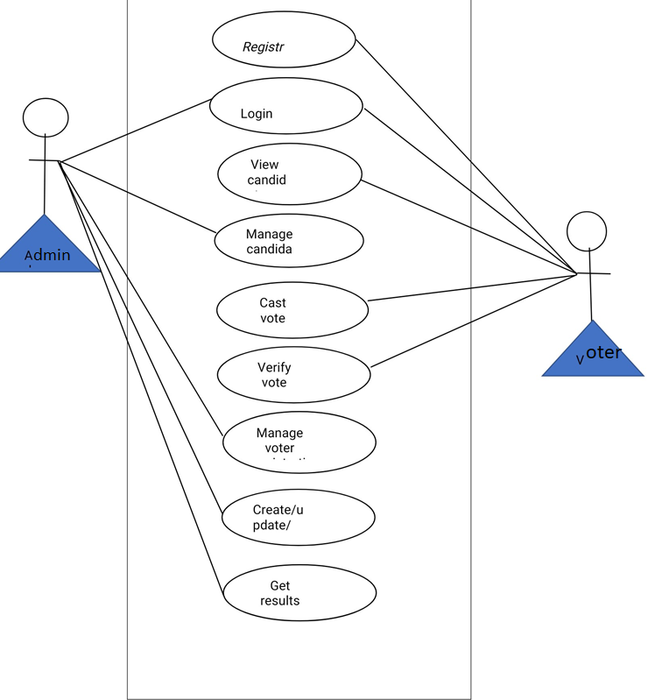
ADMIN
VOTER
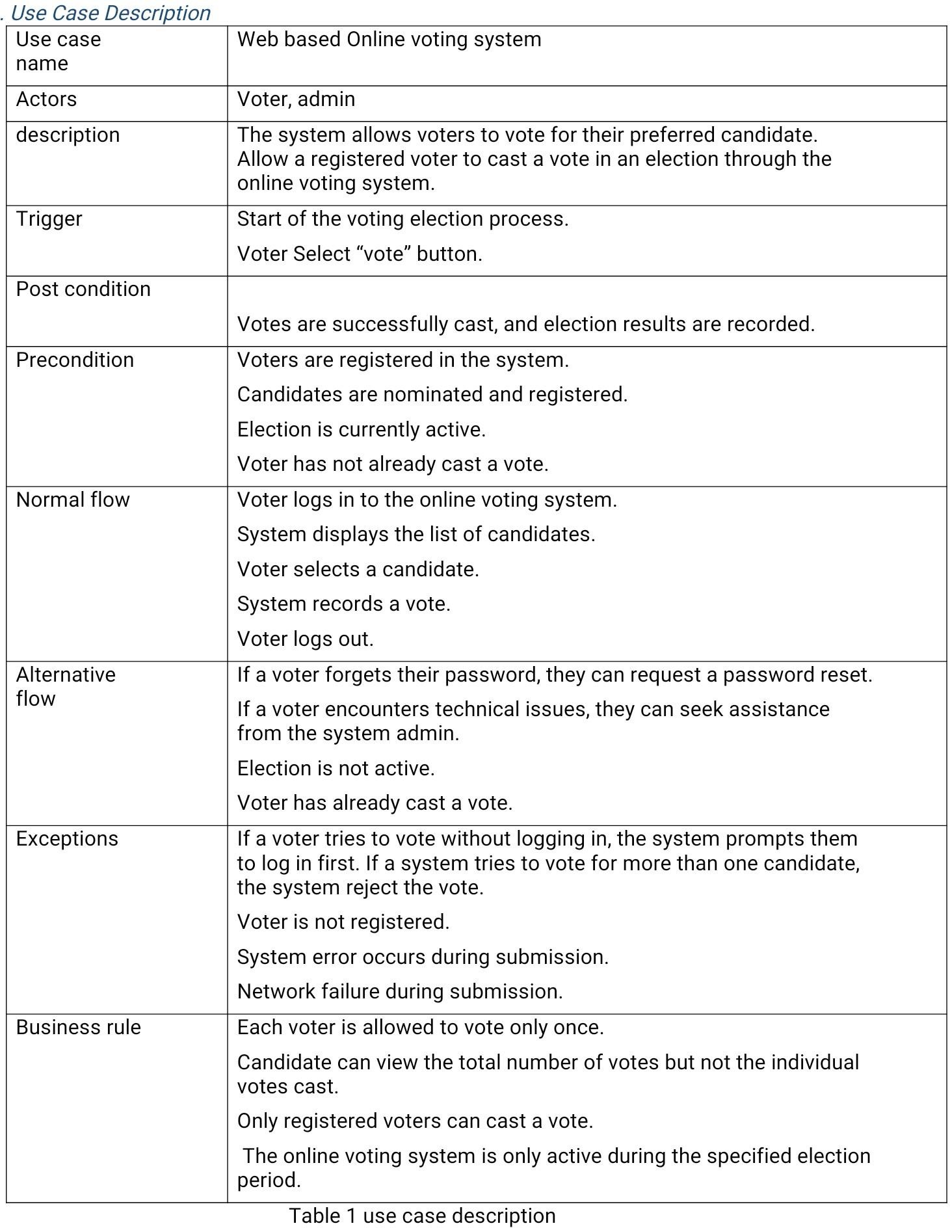

Functional Requirements:
To document the functional requirements of the online voting system, the feature-based scheme will be used for organization. Each feature represents a significant capability of the system, and the specific functional requirements under each feature detail how the system supports or implements that feature. This approach ensures clarity and comprehensiveness while aligning with the Use Case technique used to identify requirements.

System Features and Functional Requirements

1. User Registration:
- The system shall allow new users to register by providing personal information, including name, national ID, email, and password.
- The system shall validate the user's information before registration is complete.
- The system shall send a confirmation email upon successful registration.

2. Voter Authentication:
- The system shall provide a secure login mechanism requiring a registered email and password.
- The system shall ensure multi-factor authentication (e.g., OTP sent via email) for added security.
- The system shall deny access after three failed login attempts and notify the user.

3. Voting Management:
- The system shall allow registered users to view the list of active elections.
- The system shall enable users to cast a vote for one candidate per election.
- The system shall prevent a user from voting more than once in the same election.

4. Administrative Panel:
- The system shall provide administrators with an interface to add, update, or delete voter records.
- The system shall allow administrators to create and manage elections, including defining election details and candidates.
- The system shall generate real-time reports of voter turnout and election results.

5. Security and Audit:
- The system shall encrypt all sensitive data, including passwords and voting records.
- The system shall maintain a log of all user activities, including login attempts and voting actions.
- The system shall notify administrators of any suspicious activities, such as repeated login failures.

6. User Feedback:
- The system shall allow users to submit feedback or report issues through a dedicated form.
- The system shall notify administrators of feedback submissions in real time.

Functional Requirements with Specific Features:
Below is the list of functional requirements for the online voting system, grouped by feature, along with error-handling and invalid input management. Each requirement is documented using the provided template.

Table 6 Show the functional requirement template
Category | Requirement
User Authentication | The system must authenticate users using unique credentials (e.g., voter ID and password/OTP).
Voter Registration | The system must allow eligible users to register and verify their information before voting.
Vote Casting | Users must be able to securely cast a single vote in their designated election category.
Vote Confirmation | The system must provide a confirmation receipt after the vote is successfully cast.
Candidate Management | The system must allow election administrators to manage candidate details (e.g., name, party).
Election Management | Administrators must be able to configure election dates, times, and settings.
Result Compilation | The system must accurately compile and display results in real-time after the election ends.
Audit Trail | The system must generate an audit trail to track all actions (e.g., logins, vote submissions).
Role-Based Access | Administrators, voters, and auditors must have different levels of system access.
Error Handling | The system must notify users of invalid actions (e.g., duplicate votes or expired sessions).
Support for Elections | The system must support multiple types of elections (e.g., local, state, and national).
Search Functionality | Users must be able to search for candidates or election information.
Data Export | The system must allow administrators to export election results and audit logs in common formats (e.g., CSV).
Language Support | The system must support multiple languages for users from different regions.
Session Timeout | The system must automatically log out users after a period of inactivity for security purposes.

Nonfunctional Requirements for the Online Voting System

Reliability:
- NFR-1: The system shall have an uptime of 99.9% during election periods, ensuring continuous availability for voters and administrators.
- NFR-2: In case of a failure, the system shall recover within 2 minutes to restore normal operation.

Scalability:
- NFR-3: The system shall support up to 10,000 concurrent users during peak voting times without performance degradation.
- NFR-4: The database shall handle up to 1 million voter records with efficient retrieval times of under 3 seconds per query.

Usability:
- NFR-5: The system shall provide a user-friendly interface, ensuring that 90% of users can complete a voting task without prior training or assistance.
- NFR-6: All error messages shall be clear and actionable, guiding users to resolve issues within 2 attempts.

Security:
- NFR-7: The system shall comply with industry-standard security practices, such as OWASP guidelines, to protect against vulnerabilities like SQL injection and cross-site scripting.
- NFR-8: User passwords shall be stored using a salted hash algorithm with at least 256-bit encryption.
- NFR-9: All data transmitted between clients and servers shall use HTTPS with TLS 1.2 or higher.

Maintainability:
- NFR-10: The system’s codebase shall be modular, with clearly documented APIs, ensuring that updates and bug fixes can be implemented within 2 business days.
- NFR-11: System logs shall be maintained in a standardized format to simplify troubleshooting and auditing processes.

Portability:
- NFR-12: The system shall be compatible with the latest versions of Chrome, Firefox, Edge, and Safari.
- NFR-13: The system shall be deployable on both Linux and Windows servers with minimal configuration changes.

Performance:
- NFR-14: The system shall process at least 95% of requests within the performance thresholds specified in Section 3 (Performance Requirements).
- NFR-15: The system shall generate reports with a dataset of up to 10,000 records within 5 seconds.

Accessibility:
- NFR-16: The system shall adhere to WCAG 2.1 guidelines to ensure accessibility for users with disabilities, such as providing screen reader compatibility and high-contrast options.
These nonfunctional requirements ensure the system’s quality, addressing essential attributes like reliability, usability, and security. Each requirement is specific, measurable, and verifiable, providing clear targets for development and testing.

Non functional requirement table:
Category | Requirement
Performance | The system must handle up to 1 million concurrent users during peak voting hours.
Scalability | The system should support an increase in users or geographical areas without significant performance drops.
Availability | The system must maintain 99.99% uptime during the voting period.
Security | The system must use end-to-end encryption for data transmission and ensure secure user authentication.
Usability | The interface must be user-friendly, accessible, and responsive across devices (desktop, tablet, mobile).
Reliability | The system must ensure no votes are lost or duplicated under any circumstances.
Compliance | The system must comply with local, state, and international election laws and regulations.
Accessibility | The system must meet WCAG 2.1 AA standards for accessibility to accommodate users with disabilities.
Maintainability | The system should be easy to update with patches or changes without disrupting ongoing operations.
Auditability | The system must provide a secure, tamper-proof audit trail for all voting activities.
Response Time | Voting operations (e.g., submission, results display) must have a response time of less than 2 seconds.
Data Integrity | The system must ensure all votes are securely stored and cannot be modified or deleted once submitted.
Backup and Recovery | Data backups should occur every 5 minutes, and the system should recover within 15 minutes in case of failure.
Localization | The system must support multiple languages based on the voters’ preferences.
Energy Efficiency | The system should use server resources efficiently to minimize energy consumption

Usability Requirements for the Online Voting System:

Ease of Learning:
- USE-1: The system shall include a guided tutorial for first-time users, covering tasks such as registration, logging in, and casting a vote.
- USE-2: The system shall provide tooltips or on-screen hints to assist users in completing forms correctly.

Ease of Use:
- USE-3: The voting process shall require no more than 3 clicks for a user to cast their vote once logged in.
- USE-4: The system shall allow users to navigate between different sections (e.g., elections, profile, help) with a maximum of 2 clicks from any page.

Error Avoidance and Recovery:
- USE-5: The system shall validate all form inputs in real-time, providing immediate feedback for errors such as missing fields or invalid formats.
- USE-6: Users shall be able to recover from errors during registration or voting by correcting the input and resubmitting within 2 attempts.
- USE-7: The system shall provide a "Cancel" or "Back" option on every step of the voting process, allowing users to correct choices before submission.

Efficiency of Interactions:
- USE-8: 90% of users shall be able to complete the voting process (from login to confirmation) within 3 minutes, assuming proper credentials and no errors.
- USE-9: The system shall save user preferences, such as language selection, to avoid repeated input across sessions.

Accessibility:
- USE-10: The system shall provide alternative text for all graphical elements, ensuring compatibility with screen readers.
- USE-11: The system shall include high-contrast themes and adjustable font sizes to accommodate users with visual impairments.
- USE-12: All interactive elements, such as buttons and links, shall be operable via keyboard navigation.
These usability requirements aim to ensure that the online voting system is intuitive, efficient, and accessible for a derse range of users, leading to an optimal user experience.

Performance Requirements for the Online Voting System:

User Registration:
- PER-1: 95% of user registration requests shall be processed and confirmed within 5 seconds, assuming a stable internet connection of 10 Mbps or higher.
- PER-2: Validation of user input during registration shall be completed within 2 seconds of submission.

Voter Authentication:
- PER-3: 95% of login attempts shall be authenticated within 3 seconds, including multi-factor authentication processing.
- PER-4: The system shall lock an account after three failed login attempts within 2 seconds of the third failed attempt.

Voting Management:
- PER-5: 95% of election pages (e.g., candidate lists and election details) shall load completely within 3 seconds over a 10 Mbps or faster connection.
- PER-6: Casting a vote shall be processed and recorded in the database within 2 seconds of the user’s confirmation.

Administrative Panel:
- PER-7: Administrative actions such as adding or updating voter records shall be processed within 3 seconds of submission.
- PER-8: Reports on voter turnout and election results shall be generated within 5 seconds for datasets containing up to 10,000 voters.

Security and Audit:
- PER-9: The system shall detect and log suspicious activities, such as repeated login failures, within 1 second of the event occurring.
- PER-10: All sensitive data encryption operations (e.g., password hashing) shall be completed within 2 seconds per transaction.

References:
- [ISO/IEC 27001:2013 Information Security Management Systems] (https://www.iso.org/isoiec-27001-information-security.html)
- [OWASP Application Security Verification Standard](https://owasp.org/www-project-application-security-verification-standard/)
- [WCAG 2.1 Guidelines](https://www.w3.org/TR/WCAG21/)

